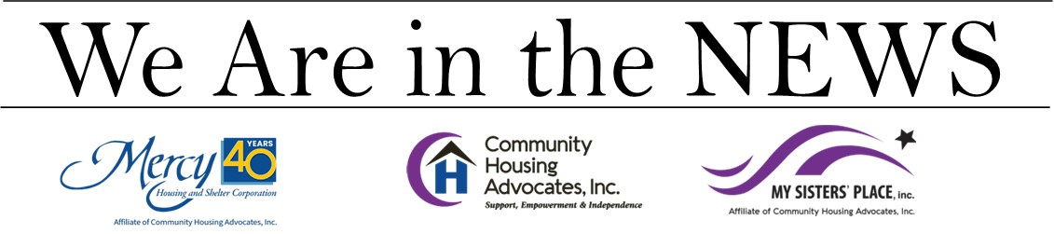
CT JOURNAL INQUIRER
June 8, 2023

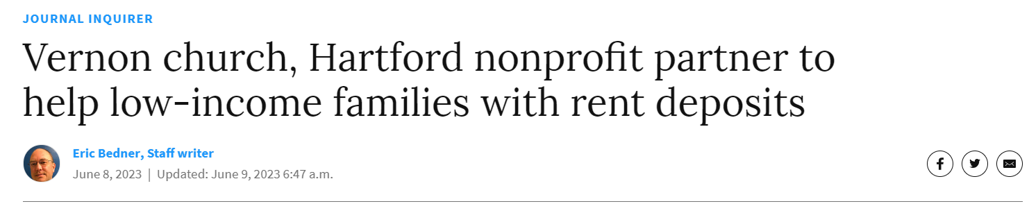
VERNON — Several low-income families have been able to find homes without having to cover the added burden of security deposits thanks to a partnership between the First Congregational Church of Vernon and Hartford-based My Sister's Place.
When raising money for infrastructure repairs to the church, organizers pledged to use some of the money to help those in need, Senior Pastor Robin Bird said, adding that "we raised far beyond what we thought" with all contributions coming from individuals.
After extensive planning to ensure the money would be used appropriately and efficiently, the church partnered with My Sister's Place, a Hartford nonprofit dedicated to ending homelessness.
The church has donated $20,000 to the organization, all of which has been used to help place families in homes.
The program aims to help Assisted Living, Income Constrained, Employed — or ALICE — households that make too much money to qualify for state aid but not enough to meet basic needs.
In Connecticut, landlords can require the equivalent of two months of rent, plus the first month's rent payment before a tenant can move in.
"That can be an astronomical number for people, and usually that security deposit is a huge barrier to people accessing housing," My Sister's Place CEO Kara Capone said.
With the funding provided through the First Congregational Church of Vernon, My Sister's Place has helped nine families with a total of 16 people afford homes.
Capone noted that inflation and the cost of rent, which has outpaced inflation in many places, has "really been problematic," exacerbating an already burdensome housing market for low-income families.
There has also been an influx of people moving to Connecticut from Boston to New York, and large property management companies buying up affordable housing.
"We're seeing huge rent increases due to that," Capone said.
My Sister's Place administers the program, vetting families and working with landlords who will accept a deposit when a tenant moves out rather than requiring it upfront.
"It's not like cash is changing hands," Bird said, adding that it's guaranteed when people move out.
Bird noted that the program is open to all who are eligible and there is no U.S. citizenship requirement.
"We open it up to whoever needs it," she said, adding that she's hopeful more churches and organizations will also contribute to the program now that is has been established and proven to work. "There's a huge need out there."
"Ultimately, our goal is to make sure that everybody has a safe place to live," Capone said. "Clearly there's more need than there are resources."
Bird credits church member Cindy Dubuque-Gallo with the foresight and her connections in social work for getting the program off the ground.
"We are thrilled that we are able to serve those who often fall through the cracks due to stringent eligibility criteria," Dubuque-Gallo said. "This program is specifically designed to assist those who may otherwise not receive any assistance but are certainly in need."
Along with money for housing, the First Congregational Church of Vernon has also used funds raised to help stock food pantries in and around Vernon during the height of the COVID-19 pandemic, and to host the first town brunch that connected residents with public officials, including the chief of police.

